**Project 5:**  
**Scheduling a basic job in Jenkins**  
  
**Task 1: Create a free style project in Jenkins**   
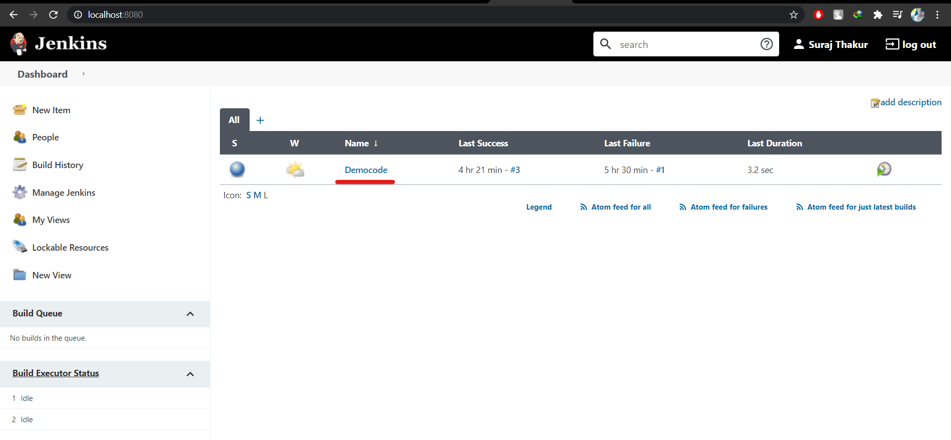  
  
  
**Task 2: Configure git SCM (Source Code Management)**   
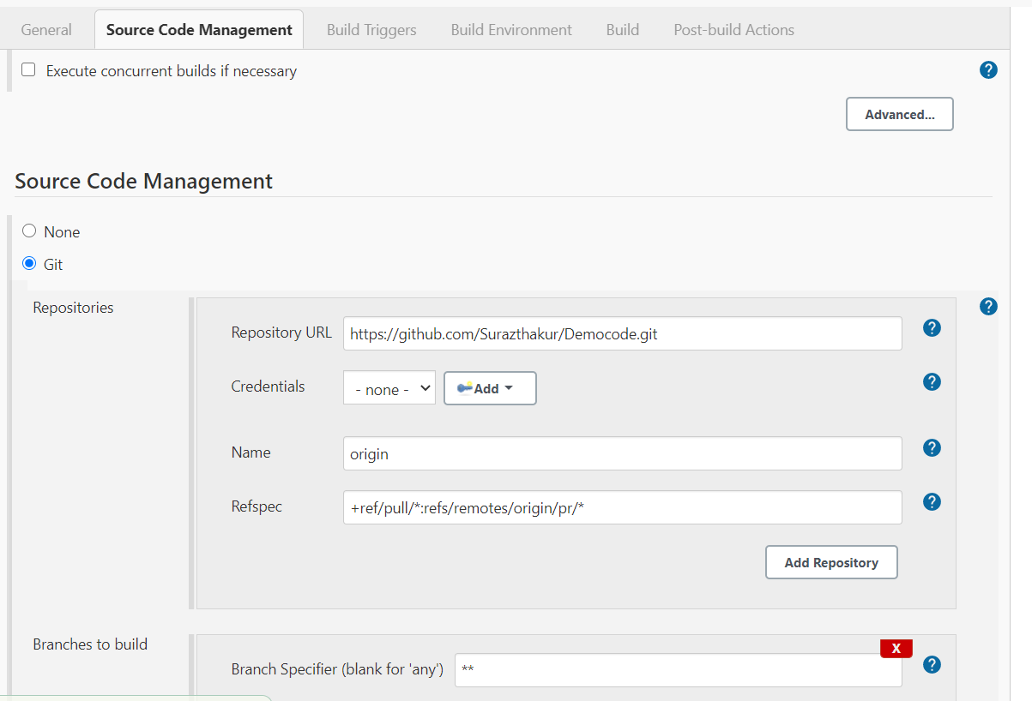  
  
  
  
**Task 3: Add build step-java commands in execute windows batch commands as shown below:**   
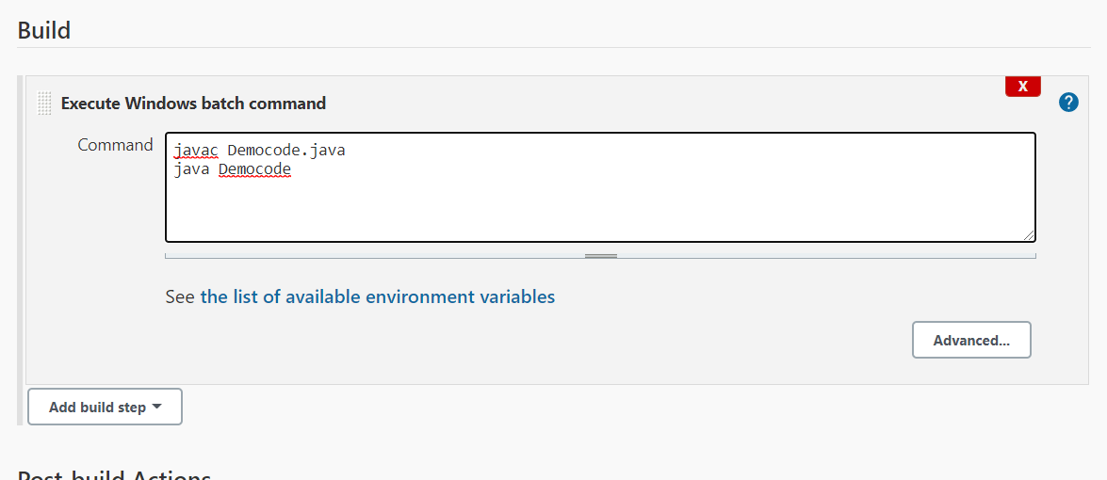

**Task 4: Run a build and show console of successful output**  
